YOUTH TEAM BACKGROUND
& APPLICATION PACK
2024-2025
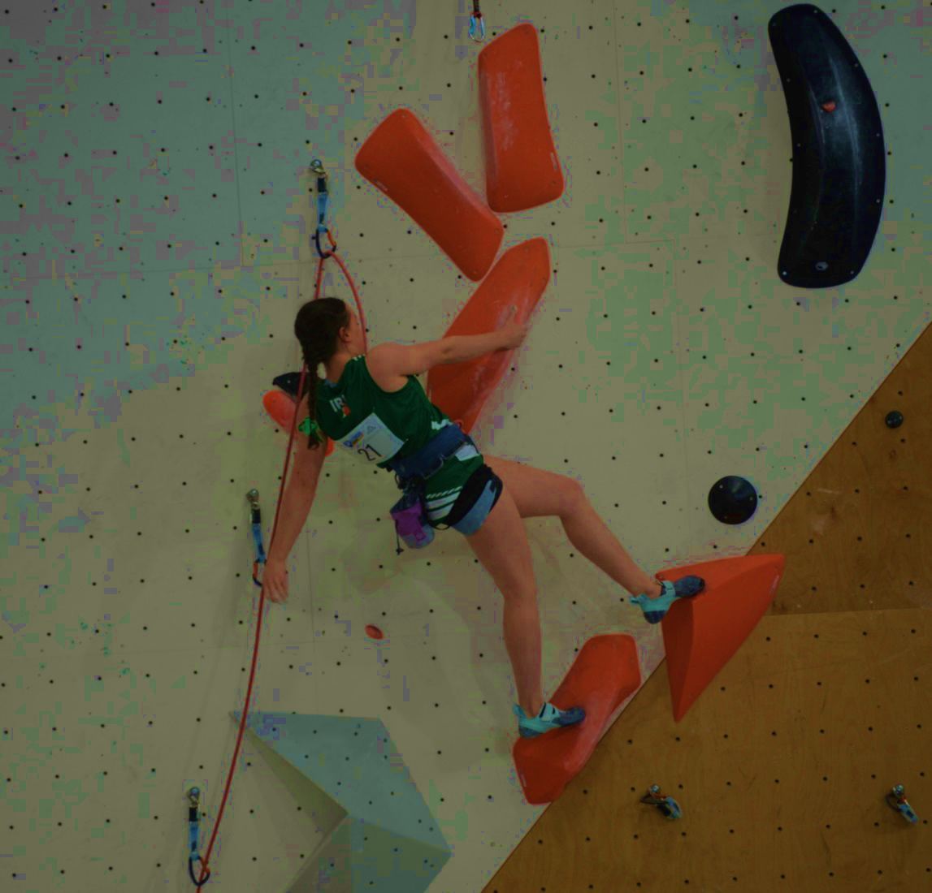

ASPIRING TO EXCELLENCE

Vision

For Mountaineering Ireland’s Talent and Performance systems, including the Youth Team, to provide opportunity for Ireland’s best climbers to train and learn together on a regular basis.

Mountaineering Ireland has been developing its performance structure over many years to support Ireland’s most talented youth climbers through climbing training and education.

In the 2024 – 2025 training year, we will enhance this system and build on the work already done to create a challenging, open and professional environment where climbers and coaches can thrive.

We aim to raise the profile of climbing in Ireland and raise the potential of young climbers by equipping them with the technical and physical skills, mindset and performance behaviours necessary to reach their full potential. In doing so we believe Ireland can develop a pipeline of youth and junior athletes who will become successful seniors representing Ireland at major championships and the Olympic Games.

The Irish Youth Team programme has supported many of the country’s top teenage climbers aged between 14-20 years with up to 8 – 10 five-hour sessions year-round at climbing walls around Ireland with a coach/climber ratio of around 1:8. Mountaineering Ireland has financially invested in its performance programme and its climbers, using some of the investment to enter individuals and teams into international competitions in Europe and to train together at camps within Ireland. The system has developed many young climbers including Dominic Burns who, in 2013, won the European Youth Climbing Championships in Boulder and was ranked 1st in the World.

Building upon all that has gone before, Mountaineering Ireland will re-launch the Youth Team Programme for 2024- 2025 with a robust application process, increased investment, enhanced athlete support and a renewed curriculum to support the athlete and their coach.

In previous years, the Youth Team has been selected at the beginning of the calendar year. From 2024, we intend to change this to align with the international competition calendar that requires climbers to be in peak condition during the summer months. From this autumn 2024, our training year will begin in the November with the first camp of the periodised year held on the 30th November and the final camp prior to the international Lead competitions that begin in May. In future years we intend to start the training year in October.

TEAM STRUCTURE FOR 2024 - 2025

For 2024-2025 athletes aged under 21 years of age will be eligible to apply for support and inclusion in the Youth Team, which has proven popular and successful with 8 – 10 training sessions per year at climbing walls around the country. The programme will continue with new innovations for 2024 - 2025 including physiotherapy input for injury prevention and a renewed climber and coach curriculum. There will be capacity for up to 12 climbers.

During 2024 – 2025 Jackie Newton, the High-Performance Coordinator, will take on the role of managing services, curriculum delivery, policies, selection and individual athlete planning for Youth Team climbers and coaches. Victoria Watterson will take on the role of Team Physiotherapist and a new Head Coach is currently being recruited to lead on technical coaching at the Youth Team sessions and at competitions.

Planning is currently underway for residential Training Camps in Europe during Easter and Summer 2024 and these will provide an excellent opportunity for 12 Youth Team and selected Youth Squad climbers, in Junior, Youth A and Youth B categories, showing the most engagement and progression, to refine their performance behaviours prior to upcoming Cups and Championships which will include; European Youth Cups and Championships and the World Youth Championships (Helsinki) in 2025 and the Youth Olympic Games in Dakar 2026.

To be successful in their Youth Team applications athletes, their parents and coaches will need to demonstrate how the support and services on offer will progress their climbing development. Climbers will be assessed for inclusion based upon their performance standards and performance potential.

This year, we are adding an annual fee for Youth Team membership at €960 paid in two instalments in December 2024 and April 2025.

YOUTH TEAM SYLLABUS FOR 2024 – 2025

- Profiling & Monitoring
- Annual Planning
- Strength & Conditioning & Performance Behaviours Curriculum
- Strength Diagnostics
- Integrated Physiotherapy
- Residential Training Camp
(Capacity for 8 - 12 climbers-to be eligible for selection).

Athlete contributions will go towards paying for international competition entry fees, wall and gym facilities and expert coaching and staffing, which is subsidised by Mountaineering Ireland. Youth Team climbers will also receive free competition, warm up and training kit.

Eligibility & Availability

For 2024- 2025, climbers aged under 21 years old on 31 December 2025 are eligible to apply for inclusion in the Youth Team. To be eligible a climber must be eligible for Ireland selection and must not yet have competed for another country at a major championship and hold a current full Irish passport.

2025 Training Syllabus for the Youth Team

 | November | December | January | March | April | May
Knowledge and understanding | Purpose of warm up (RAMP); Energy Systems; Periodisation GAS model, Linear vs undulation | Role of the physiotherapist; Technical climbing models (movement based); progression of plyometrics and relationship to climbing; the role of the trunk in posture and transfer of force; injury prevention | Role of the physiologist, Energy systems and recovery, purpose and execution of climbing drills | Role of the nutritionist, Nutrition and hydration, Relationship of S&C to climbing economy | Progression of S & C | Competition day planning, peaking and tapering, travelling for comp, food and hydration
Physical Preparation | Fundamental Movement skill; Dynamic Warm up; landing ability; Landing; Pre-season: S&C | Climbing drills and basic plyometrics, development of lumbo pelvic control exercises, finger and lower arm strength health | Development of climbing drills and intermediate plyos, recovery strategies | Introduction to load | Refine/intensify S & C, climbing drills through microdosing | Maintaining S & C, climbing drills
Climbing Session | Climbing conditioning | Practice of technical models | Aerobic climbing session | Anaerobic climbing session | Anaerobic Climbing Session | Comp Simulation
Performance behaviours |  | Lifestyle factors to help with injury prevention, frequency vs intensity; Acute chronic workload ratio (ACWR) for managing fatigue. | Sleep and recovery techniques | Nutrition and hydration | Role models and performance mindset | Travel strategies
Monitoring | Movement screening | Lower arm capacity and finger capacity (critical force test) | Technical analysis of drills, Match HR with Lactate levels and pace. | Determine HR and pace at threshold (determined by lactate) | Progression of S&C | Hydration - osmocheck
Athlete resources | Dynamic Warm up, own review and goal setting document | Technical models, lumbo pelvic control circuit, lower arm and finger exercise sheet | Climbing drills | Nutrition and hydration notes and charts | 2 X S & C sessions | Pre Competition resource, drills resource.
Additional personnel | S&C and physio staff to lead movement screening | Physiotherpist and coaches to lead on drills | Physiologist and coaches to lead on drills | Nutritionist, Phyisical prep qualified staff | S & C coach
Venue | TBC | TBC | TBC | University of Limerick TBC | TBC | TBC
Follow up | Movement screen, ROM, Y-balance | Videos of technical content | Personal lactate chart with pace and HR progressions | Lactate and HR levels at threshold | Progression of S&C | Pre Competition reminders before key championships

Competition programme for Youth Team
Youth Team members will no longer be eligible for the Youth Climbing Series (YCS). The YCS aims to develop climbers at the level below the Youth Team.

Youth Team members will be expected to prioritise and compete in the below competitions:
- Irish Boulder Championships
- Irish Lead Championships
- Junior British Boulder Championships
- Junior British Lead Championships
- G Force
- CWIF
- Scottish Boulder Championships
- Scottish Lead Championships

Selections will be made for each European Youth Cup and European Championships from members of the team. Selection will be primarily based on results in nominated competitions and will be subject to an assessment of performance standards against what it takes to make a final at European Cup level and a semi-final at European Championship level. Please note, the selection panel may choose not to select for all available positions at a competition, if climbers have not demonstrated potential for final or semi-final positions.

APPLICATION & SELECTION

The Team programme aims to support climbers who, with their coaches, have identified their own strengths, weakness and areas for progress over the next 3-5 years and who will benefit most from engaging with the physical preparation, physiotherapy, technical skill and performance lifestyle support available. Selection will prioritise climbers who demonstrate the potential and desire to represent Ireland at a senior international competition including the Olympic Games.

Selection Criteria

Performance
Reported in the form below, Boulder and Lead performances with athlete trajectory will be assessed by comparison to results and standards at European Cup and Championship level for those U21, plus Junior British Lead Championships (JBLC), Junior British Boulder Championship (JBBC), Irish Championships, G Force, CWIF, Scottish Boulder Championships and Scottish Lead Championships for those U19 and include the Youth Climbing Series Grand Final for those U17 as per the table below.

 | Results taken into consideration
U21 | European Cup results
U19 |  | British Champs and Irish Champs, G Force and UK competitions CWIF, Scottish Boulder and Scottish Lead Championships
U17 |  |  | Youth Climbing Series Grand Final

Potential
A panel of experts led by the Head Coach and overseen by the High-Performance Coordinator, will discuss each climber's performance potential based upon information provided in the application form relating to:

- Relative training age
- Coaching relationship and environment
- Training history
- Training gap analysis
- Motivation
- Commitment to climbing
- Availability to engage with the programme for maximum impact
- Injury history

The selection panel will also be aware of and discuss maturation and peaking ages in different. disciplines.

Selection Process
- Climbers who apply will be compared to each other based on performance standards, potential to progress and the likely impact of engagement with the programme.
- Climbers will then be ranked in priority order for selection to the Team.

Retention
Each climber will be evaluated after one year in the Team and invited to reapply demonstrating their progress and ongoing commitment to climbing. Ideally climbers who are progressing their performances would remain in the Team for four years before transitioning to the Mountaineering Ireland Senior Team. The Youth Team programme has a four-year curriculum.

APPLICATION

Climbers should meet with their coach or, for those in the Irish Youth Squad, with one of the squad coaches, to complete the form below and return by email to jackie@mountaineering,ie by 25th October 2024 at 6pm. Questions can be emailed to jackie@mountaineering.ie

To apply for Mountaineering Ireland Youth Team support for 2024-2025 please answer all questions below and tick all applicable boxes. We recommend that parents of U18 climbers are closely involved in the application process.

My Profile

Age:
DOB:
School or University Year in September 2024:
Coach:
Home Town:
Normal Training Location:

Boulder | Lead
2022 PB: date; | 2022 PB: date;
2023 PB: date; | 2023 PB: date;
2024 PB: date; | 2024 PB: date;

How many years have you been training for climbing?

Please underline which of the following you have experience of:
- Keeping a training diary
- Climbing drills
- Regular gym-based strength training (weekly)
- Core training at home

If you played other sports outside of PE/Climbing in 2024, explain the level you participated at and training frequency…

My Climbing Training in 2023-2024

Describe a sample week of training from October 2023

Mon | Tues | Weds | Thurs | Fri | sat | Sun

Describe a sample week of training from March 2024

Mon | Tues | Weds | Thurs | Fri | sat | Sun

Number of sessions completed with your coach present in a typical week:

Which of the following did you compete in in 2023 - 2024? Please underline…
- YCS series
- YCS Grand Final
- G Force
- CWIF
- Scottish Boulder Championships
- Scottish Lead Championships
- Irish Boulder Championships
- Irish Lead Championships
- Junior British Boulder Championships
- Junior British Lead Championships
- European Cups
- European Championships

My Injury History
Please list any injuries you had since October 2023 and number of training days lost through this injury or competitions missed. If you know the name of the injury please include it and the name of your physiotherapist if you attended one.

My Eligibility
Please confirm that you hold a full Irish passport Y/N

Please either complete the first statement below or underline the bottom statement

I have represented Ireland at……………….

I have not yet represented Ireland

Please complete the paragraphs below

Athlete Statement
My short-term goal in climbing is…

My long-term goal in climbing is…

I feel the Youth Team programme would benefit me because…

Coach Statement:
To bridge the gap to international representation, at European Cup level, I feel this climber needs to……

I feel the most beneficial aspects of Team inclusion for this climber will be……

After review of applications received by 6pm on 25th October there will be a selection process and successful applicants will be contacted and made an offer of Team support for 2024-2025. This offer will be made within two weeks of the application window closing. We are planning our first training day on 30th November (tbc) so applicants should keep this date free to allow them to attend if they are selected.

Once an offer is made to the climber, they will be able to assess that offer and their availability to attend at the proposed times before paying the first instalment of the Climber Contribution fee for 2024 – 2025 of €480 (€480 X 2 = €960) and confirming their inclusion. Climbers who would like to be considered for a fee waiver based on financial hardship may state this, in confidence, when returning their application.

Applications may be typed or handwritten but must be emailed to jackie@mountaineering.ie to arrive by 6pm 25th October 2024

Mountaineering Ireland intend to communicate with all applicants by 11th November.

