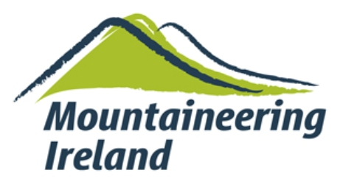
Women In Sport – Funding Application

Section 1 – The applicant
Name
Address

Phone number
Email
Date of birth
Mountaineering Ireland membership number

Section 2 – Details of training
Type of course / assessment
Approximate date (MM/YY)
Course / assessment fee (please give estimate if not confirmed)

Section 3 – Motivation
Please outline how funding support would help you on your training journey (200 words maximum).

Have you previously received Women in Sport funding support from Mountaineering Ireland?
Yes ☐
No ☐
If yes, please provide details.

One of the core pillars of the Women in Sport programme is to promote the visibility of women in sport. To further this aim, can you endeavour to provide photos and/or text for the Irish Mountain Log or Mountaineering Ireland’s social media about your training journey? (Your name / photo does not have to be included in this).
Yes ☐
No ☐

Has the training already been completed?
Yes ☐
No ☐
If ‘Yes’, please attach a receipt from the course provider confirming details of training carried out and cost. If ‘No’, a receipt for completed training should be received within 6 months of the grant approval.

I confirm that all the facts outlined on this application are correct.

Signed: _________________________________________ Date: ____________________

Please return completed form to info@mountaineering.ie or by post to Mountaineering Ireland, Irish Sport HQ, National Sports Campus, Blanchardstown, Dublin 15, D15 DY62.

