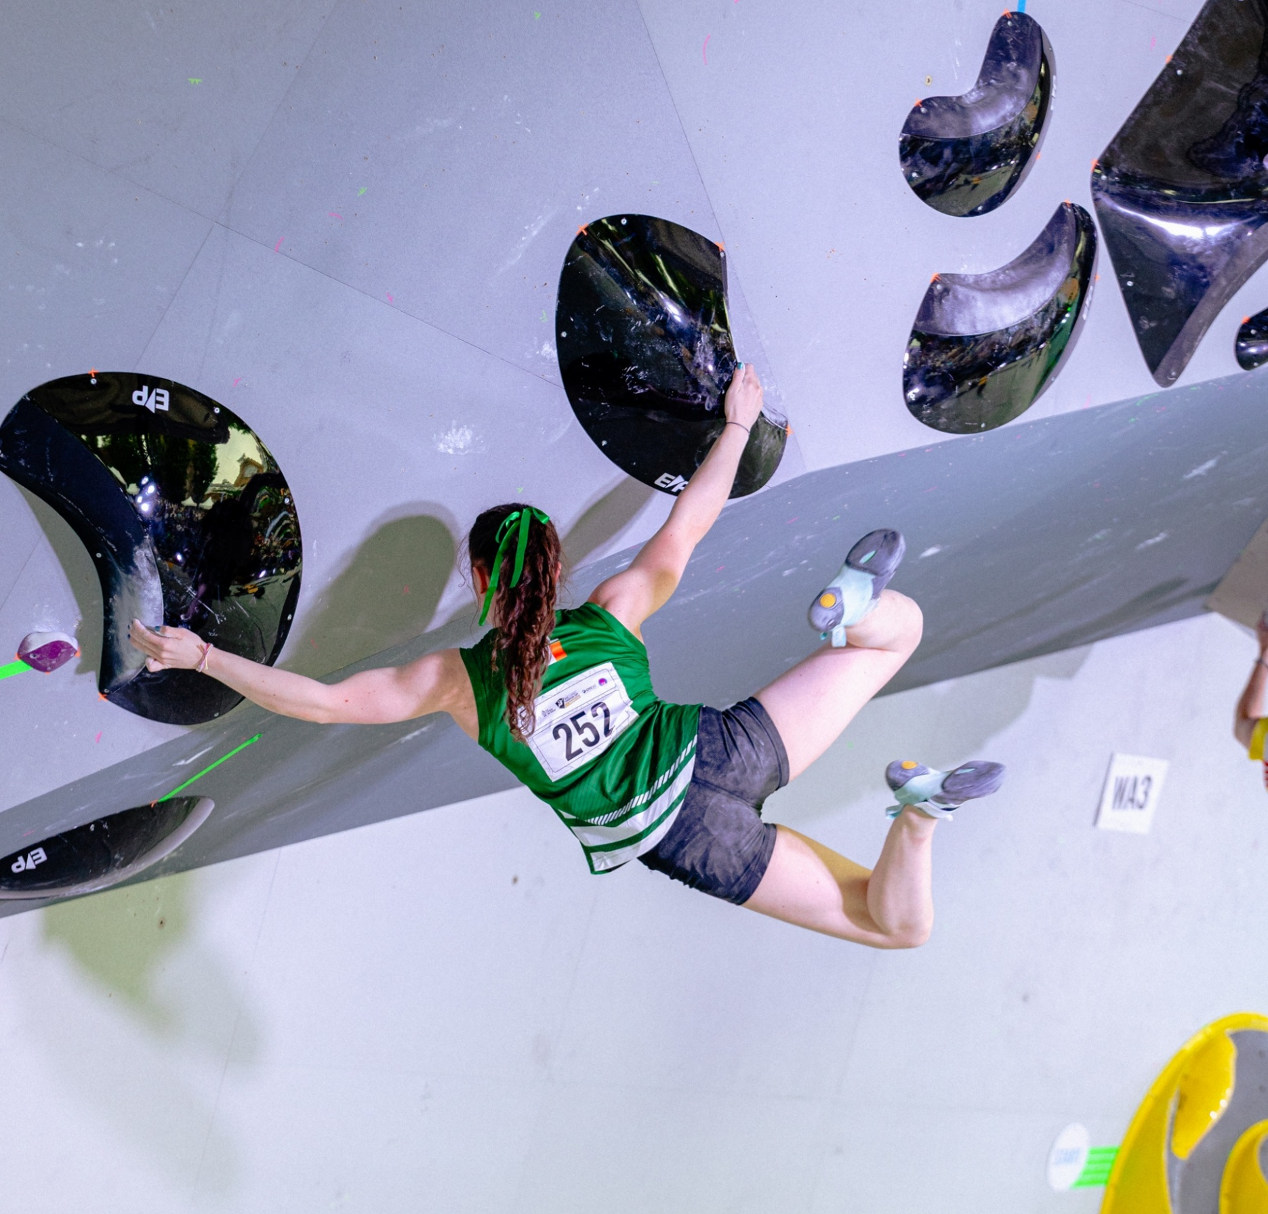

Youth Climbing Team
Application Pack
2026

Vision

Mountaineering Irelands High-Performance Team aims to raise the profile of competitive climbing in Ireland by facilitating climbers to be competitive on the National, European and World stage and so inspire the entire population.

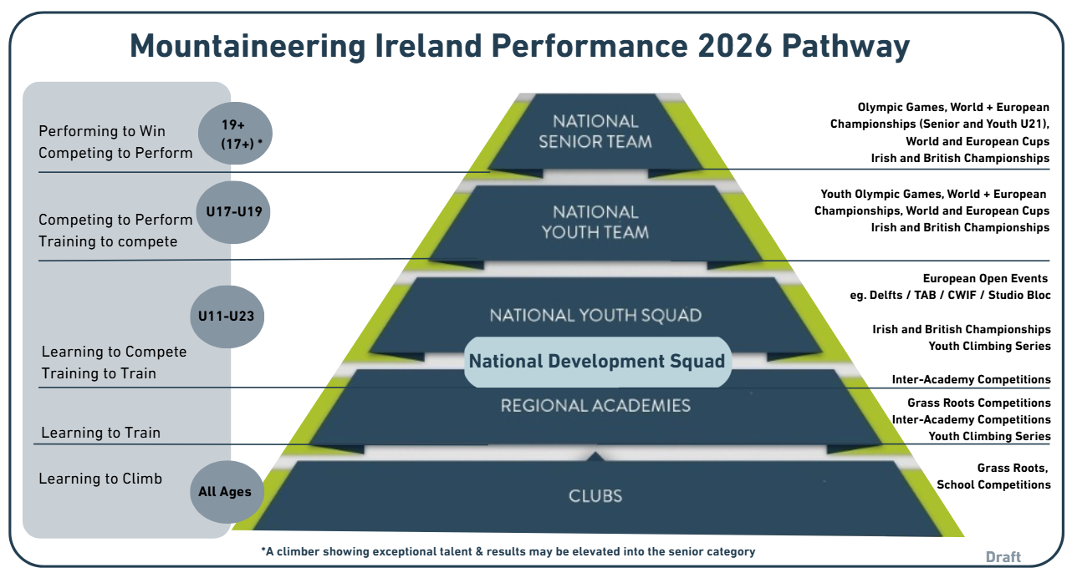

Mountaineering Ireland's Performance Pathway Programmes include the Irish Development Squad, Irish Youth Squad, the Youth Team and the Senior Team. The aim of the system is to support Ireland’s climbers on each tier of the pathway with the comprehensive support required to help them develop into confident and skilled climbers with ability to reach their full potential. Nationally, our goal is Olympic success and to reach a level where we will be considered a high-performance focus sport in the Sport Ireland system with support for sports science, medicine and carded funding for climbers. As part of their preparation for major championships, it is crucial for athletes to work on the determinants for success with support from integrated services, domestic and international camps and competitions. Being a part of the Sport Ireland High Performance system will bring this support and accelerate progress towards our long-term goals:

- To produce one European finalist by 2026
- To have a climber qualify for the Olympic Qualifying Series by 2028
- To have a climber qualify for the Olympics by 2032

The Mountaineering Ireland Youth Team for 2026 is for the country’s elite top performing young climbers in preparation towards International Level Competition. The 2026 programme will be targeting climbers who are capable of achieving finals at European Youth Cup Level in 2026 and have shown proven track record of results to support this. This programme will be funded by Mountaineering Ireland, Sport Ireland and through an annual Athletes participation fee. It will offer a comprehensive support system for athletes

including coaching expertise and centralised training camps. S&C and Physical Therapy support will also be provided, at critical times of the year.

Individual competition support for those that fulfil selection criteria for each competition will also be provided by the Performance Team. The selection policy for European Youth Cups and Youth World Championships will be published by 31st Dec 2025. (Please note the selection policy is currently under review). Selection policy for Youth Olympic Games 2026 will be dependent on IFSC guidelines for this event and will be published as soon as possible.
The selection philosophy aims to challenge climbers to raise their levels of performance, achieve standards required and be recognised at the same level as other sports within in the Sport Ireland High Performance system.

With our Olympic ambition in mind, Mountaineering Ireland are launching the Youth Team Programme for 2026 and are asking climbers to demonstrate their future International potential through performance data and evidence of potential.

Youth Team Structure for 2026

For 2026, climbers eligible to compete for Ireland in the 2026 European Youth Cups may apply for inclusion in the Youth Team Programme. Climbers aged 15 to 19 years old will be considered for this category. Only athletes who meet the criteria will be selected. Exceptional athletes from the Youth Squad tier who have displayed outstanding results, progression and potential throughout the season may also be elevated to the Youth Team Programme at any time during the season at the discretion of the selection team.

The High Performance Management team will be made up of the Performance Lead who will lead the program, manage services, update policies and oversee the selection process. A High Performance Coaching Consultant will be involved in the selection process and competition strategy for the 2026 season. Our coaching Team will comprise one Head Coach / Competition Coach, who in conjunction with the High Performance Support Team will support individual planning, training camp delivery, competition support, athlete feedback and selection for competitions.

The first official training camp of the team including both Youth and Senior Team members (4 days) is scheduled for Jan. 2026, date and venue to be confirmed. Additional Training Camps will be organised throughout the year, dates and locations to be confirmed after team selection. These training camps will provide an excellent opportunity for Youth Team and Senior Team climbers to work on their climbing progression and to refine their performance behaviours prior to upcoming European Cups.

To be successful in their applications, climbers will need to demonstrate how the support and services on offer will progress their development to achieve the results required to help Mountaineering Ireland achieve our long-term goals. Climbers will be assessed for inclusion based upon their performance standards and performance potential, next to their work-ethics and commitment to the programme.

The Youth Team Membership fee for 2026 is €960 paid in two instalments in January 2025 and April 2026.
This athlete contribution will go towards IFSC registrations, specialist coaching and athlete support, wall and gym hire, route-setting, team kit it and to subsidise travel and accommodation for overseas competitions and camps.

As part of the athlete agreement, it is mandatory that National Team athletes compete in both the Irish National Bouldering and Lead Championships and also attend at least one of the Youth Squad or Development Squad Camps throughout the year. Mountaineering Ireland will reimburse athletes €480 in August 2025 to cover personal costs associated with competing in the Irish Bouldering Championship and Irish Lead Championship and in travelling to the Youth or Development Squad Camps.

APPLICATION & SELECTION

The Youth Team programme aims to support climbers who have identified their own strengths, areas of improvement and areas for progress over the next 1-5 years and who will benefit most from engaging with the support available. To be successful in their Youth Team applications athletes, their parents and coaches will need to demonstrate how the support and services on offer will progress their climbing development. Climbers will be assessed for inclusion based upon their performance standards and performance potential.

SELECTION CRITERIA

Performance

Performances reported in the form below will be assessed by comparison to (Youth) Olympic Games, (Youth) World Championship, European Championship, World Cup and (Youth) European Cup standards.

Potential

A panel of experts led by the High-Performance Lead will evaluate each climber's performance potential based upon information provided in the application form relating to:

- Training age
- Training history
- Training gap analysis
- Performance trajectory
- Coaching relationship and environment
- Commitment to achieving excellence
- Commitment to help Mountaineering Ireland achieve its targets
- Availability to engage with the programme for maximum impact
- Injury history

In addition to information on performance trajectories, the selection panel will also be aware of and discuss maturation and peaking ages in the three Olympic disciplines.

Selection Process

- Climbers who apply will be compared to each other based on performance standards, potential to progress and the likely impact of engagement with the programme.
- Climbers will then be ranked in priority order for selection to the programmes.

Retention
Each climber will be evaluated after one year in the programme and invited to reapply demonstrating their progress and ongoing commitment to the targets.

APPLICATION

Climbers should meet with their current coach to complete the form below and return by email to eimir@mountaineering.ie by Wednesday 10th Dec. Questions can be emailed to eimir@mountaineering,ie

To apply for Mountaineering Ireland Youth Programme inclusion for 2026 please answer all questions below and tick all applicable boxes. We recommend that climber and coach meet to complete this form along with anyone else closely involved in the application process.

MY PROFILE:

Age:
DOB:
School or University Year in Sept 2025
Contact email:
Contact telephone:
Coach:
Coach contact:
Hometown:
Normal Training Location:
Competition Gender:

How many years have you been training for climbing?

If you played other sports outside of PE/Climbing in 2024, explain the level you participated at and training frequency…

RESULTS HISTORY:

Please include your top results for the previous 5 years. The following competitions will be considered:

European Youth Cup / Youth World Championship
Irish Bouldering Championships / Irish Lead Championships
UK Bouldering Championships / UK Lead Championships
Scottish Bouldering Championships / Scottish Lead Championships
European Open Events eg CWIF, Delfts, Studio Bloc, etc
Domestic Open Events eg. G-Force, Blockstock, Craic Mor, Big Bang, etc.

Record of Results:
Main event: Boulder / Lead / Speed | Secondary Event: Boulder / Lead / Speed
2021 PB: date: | 2021 PB: date:
2022 PB: date: | 2022 PB: date:
2023 PB: date: | 2023 PB: date:
2024 PB: date: | 2024 PB: date:
2025 PB: date | 2025 PB: date:

SHORT TERM GOALS
Please highlight the Competitions and standards you are aiming for in 2026 and 2027.

Competition | Target result/standard
Irish Bouldering Championships
Irish Lead Championships
UK Bouldering Championships
UK Lead Championships
Youth European Cup
Youth World Championship
Youth Olympic Games
(add others as relevant)

LONG TERM GOALS

Please see below, Mountaineering Ireland’s long-term targets. Please highlight the target that most closely matches your own long-term target that you feel you will help us to achieve:

2026 European Cup/Championships | 1 X Finalist at European Cup (Youth and Senior)  1 X Semi-finalist at European Champs  1x Finalist Youth World Championship  1 x Finalist at Youth Olympic Games
2027 World Cup Series | Athletes achieving top 40 positions
Olympic Games 2028
  Total number of Irish climbers qualifying for the Olympic Climbing Series = 1
Olympic Games 2032
  Total number of Irish climbers competing at the Games = 1

Please provide a detail of your training (including environment), performance lifestyle and any injury prevention/rehabilitation that you have worked on. Please highlight any previous areas of engagement with Mountaineering Ireland that have supported your improvements and a move towards standards.

Climber-Coach Relationship / Partnership
Please comment on the areas that work well in your relationship and any areas that need to be addressed.
Physical Preparation

Please comment on the effectiveness of your S & C programme/physiological interventions / rehabilitation training etc.
Technical Preparation

Please assess your technical ability in relation to world class climbers in your event. Please also note any biomechanical issues.

Tactics
Please comment on your tactical ability in competition performance
Performance Psychology
Please comment on your ability to perform under pressure.
Competition Planning
How would you normally plan your competition season?
Sports Medicine
How effective was your use of physiotherapy, prehab, soft tissue, RED-S education, blood diagnostics etc.
Nutrition
Please assess the effect of your nutritional habits on performance
Performance Lifestyle Planning
Assess how your non-training time contributes to your performance. Please comment on sleep, recovery, effective use of funding, how your employment or education status supports your training

Please explain your areas of focus for 2026 and any risk or limiting factors that you need to address:
Tactics and performance psychology on the international stage, limiting factors is the ability to train these at an adequate standard here in Ireland. Such as mock comps etc.

Please explain how you expect to be selected or qualify for your long-term target competitions by achieving standards or by targeting competitions and maximising your performance and ranking.

Please outline funding you receive from other organisations.
Please complete the paragraphs below
Athlete statement:

My short-term goal is –

My long-term goal is –

Inclusion in the programme will benefit me because –

Coach statement:

To bridge the gap to World Class standard, I feel the climber needs to –

The most beneficial aspects of the programme for this athlete will be –

After review of applications received by midnight 10th December, the selection process will take place, after which successful applicants will be contacted and made an offer of inclusion for the 2026 Programme. Climbers selected onto the programme will also be expected to provide an annual plan to help determine the level and type of support required.

Applications may be typed or handwritten and then scanned and must be emailed to eimir@mountaineering.ie by midnight 10th December 2025. Late applications will not be accepted. Mountaineering Ireland intend to communicate with all applicants by 20th December 2025.

