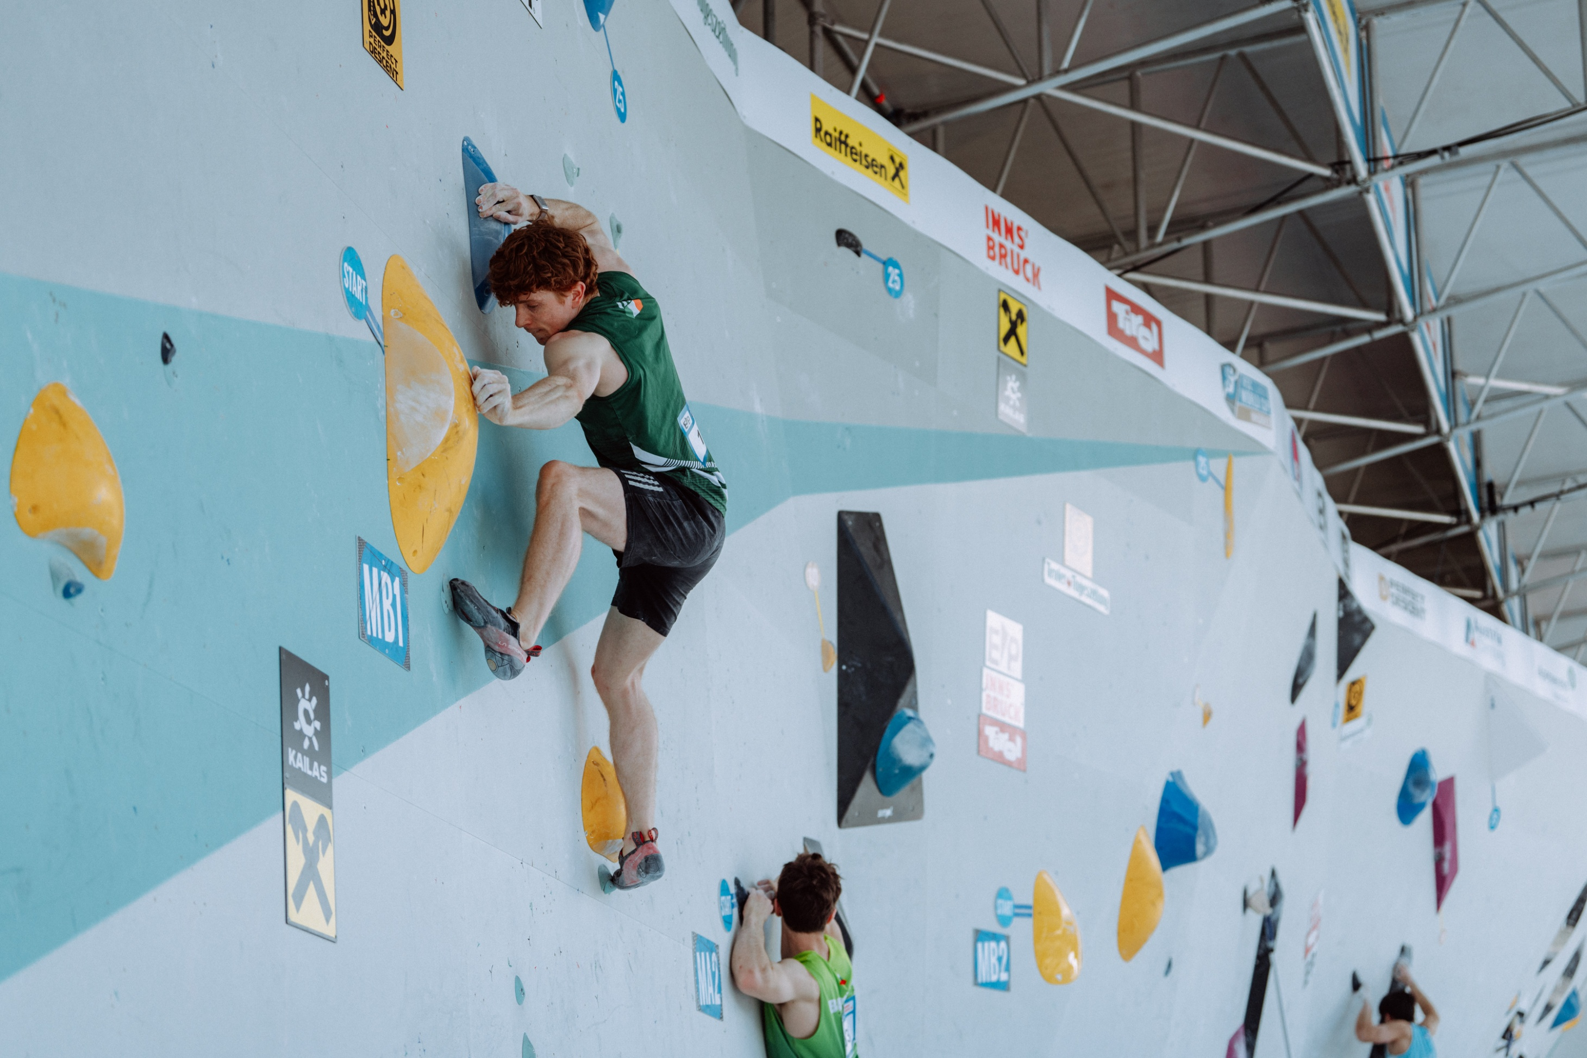

SENIOR CLIMBING TEAM
APPLICATION PACK
2025-2026

Vision

Mountaineering Irelands High-Performance Team aims to raise the profile of competitive climbing in Ireland by facilitating more of our climbers to be competitive on the European and World stage and so inspire the entire population.

Mountaineering Ireland's Performance Pathway Programmes include the Irish Youth Squad, The Youth Team and the Senior Team. The aim of the system is to support Ireland’s best climbers towards Olympic success and to reach a level where we will be considered a high-performance focus sport in the Sport Ireland system with support for sports science, medicine and carded funding for climbers. As part of their preparation for major championships, it is crucial for athletes to work on the determinants for success with support from integrated services and overseas camps and competitions. Being a part of the Sport Ireland High Performance system will bring this support and accelerate progress towards our long-term goals:

- To produce one European finalist by 2026
- To have a climber qualify for the Olympic Qualifying Series by 2028
- To have a climber qualify for the Olympics by 2032

The Mountaineering Ireland Senior Team is for the country’s elite top performing climbers, providing support in preparation towards International Level Competition. This program funded by Mountaineering Ireland, Sport Ireland and through an annual Athletes participation fee offers a comprehensive support system for athletes including coaching expertise and centralised training camps. S&C and Physical Therapy support is also provided, at critical times of the year.

Individual competition support for those that fulfil selection criteria for each competition will also be provided by the Performance Team. The selection policy for European Cups, World Cups and Championships will be published towards the end of the year 2025. (Please note the selection policy is currently under review).
The selection philosophy aims to challenge climbers to raise their levels of performance, achieve standards required and be recognised at the same level as other sports within in the Sport Ireland High Performance system.

With our Olympic ambition in mind, Mountaineering Ireland are launching the Senior Team programme for 2026 and are asking climbers to demonstrate their future Olympic potential through performance data and evidence of potential.

SENIOR TEAM STRUCTURE FOR 2026

For 2026, climbers eligible to compete for Ireland in the 2026 European Cups may apply for inclusion in the Senior Team Programmes.

All climbers aged 19+ will be considered for this category. Exceptional climbers (Tier 1 athletes) from age 17(athletes turning 17 in 2026) may also be elevated to this programme from the Youth Team at any time based on exceptional performance and potential. The programme for 2025 - 2026 will build on the innovations started in the previous season including our Head Coach, S&C and Physical Therapy input for injury prevention. There will be a capacity for up to 12 climbers. Only athletes who meet the criteria will be selected.

The High Performance Management team will be made up of Performance Lead who will lead the program, manage services, update policies and oversee the selection process. The Head Coach in conjunction with the High Performance Coaching and Physiotherapy Team will support individual planning, athlete testing, training camp delivery, competition support, athlete feedback and selection for competitions.

The first training camp is currently planned for the 17-19.10.2025 in Dublin. Monthly training camps (2-2.5 days) led by the Head Coach & Performance Team will take place throughout the year. These will take place in Ireland or in other High Performance Venues in Europe. An extended training Camp will be organised for around 19. - 22.12.25tbc (U19-Senior). These training camps will provide an excellent opportunity for Senior Team and Youth Team climbers to work on their climbing progression and to refine their performance behaviours prior to upcoming European Cups.

To be successful in their applications, climbers will need to demonstrate how the support and services on offer will progress their development to achieve the results required to help Mountaineering Ireland achieve our long-term goals. Climbers will be assessed for inclusion based upon their performance standards and performance potential, next to their work-ethics and commitment to the programme.

In 2026, we will have an annual fee for Senior Team membership at €960 paid in two instalments in December 2025 and April 2026.

Contribution’ will go towards specialist coaching, wall and gym hire, route-setting, physiotherapy and kit with any left-over budget used to subsidise travel and accommodation for overseas competitions and camps.

Eligibility & Availability

For 2026, climbers eligible to compete for Ireland in the 2026 European Cups may apply for inclusion in the Senor Team Programmes.

APPLICATION & SELECTION

The Senior Team programmes aims to support climbers who have identified their own strengths, areas of improvment and areas for progress over the next 1-5 years and who will benefit most from engaging with the support available.

Selection Criteria

Performance
Performances reported in the form below will be assessed by comparison to Olympic Games, World Championship, European Championship, World Cup and European Cup standards

Potential
A panel of experts led by the High-Performance Coordinator will discuss each climber's performance potential based upon information provided in the application form relating to:

- Training age
- Training history
- Training gap analysis
- Performance trajectory
- Coaching relationship and environment
- Commitment to achieving excellence
- Commitment to help Mountaineering Ireland achieve its targets
- Availability to engage with the programme for maximum impact
- Injury history
In addition to information on performance trajectories, the selection panel will also be aware of and discuss maturation and peaking ages in the three Olympic disciplines.

Selection Process
- Climbers who apply will be compared to each other based on performance standards, potential to progress and the likely impact of engagement with the programme.
- Climbers will then be ranked in priority order for selection to the programmes.

Retention
Each climber will be evaluated after one year in the programme and invited to reapply demonstrating their progress and ongoing commitment to the targets.

APPLICATION

Climbers should meet with their current coach to complete the form below and return by email to eimir@mountaineering.ie by Sunday 30th September. Questions can be emailed to eimir@mountaineering,ie

To apply for Mountaineering Ireland programme inclusion for 2026 please answer all questions below and tick all applicable boxes. We recommend that climber and coach meet to complete this form along with anyone else closely involved in the application process.

My Profile

Age:
DOB:
Contact email:
Contact telephone:
Coach:
Coach contact:
Hometown:
Normal Training Location:

Main event: Boulder / Lead / Speed | Secondary Event: Boulder / Lead / Speed
2021 PB: date: | 2021 PB: date:
2022 PB: date: | 2022 PB: date:
2023 PB: date: | 2023 PB: date:
2024 PB: date: | 2024 PB: date:
2025 PB: date | 2025 PB: date:

Short term goals

Please highlight the Competitions and standards you are aiming for in 2026 and 2027.

Competition | Target result/standard
Irish Bouldering Championships
Irish Lead Championships
UK Bouldering Championships
UK Lead Championships
European Cup
World Cup

Long term goals

Please see below, Mountaineering Ireland’s long-term targets. Please highlight the target that most closely matches your own long-term target that you feel you will help us to achieve:

2026 European Cup/Championships | 1 X Finalist at European Cup  1 X Semi-finalist at European Champs
2027 World Cup Series | Athletes achieving top 40 positions
Olympic Games 2028 | Total number of Irish climbers qualifying for the Olympic Climbing Series = 1
Olympic Games 2032 | Total number of Irish climbers competing at the Games = 1

Please provide a detail of your training (including environment), performance lifestyle and any injury prevention/rehabilitation that you have worked on. Please highlight any previous areas of engagement with Mountaineering Ireland that have supported your improvements and a move towards standards.

Climber-Coach Relationship/Partnership
Please comment on the areas that work well in your relationship and any areas that need to be addressed.
Physical Preparation

Please comment on the effectiveness of your S & C programme/physiological interventions/rehabilitaton training etc.
Technical Preparation

Please assess your technical ability in relation to world class climbers in your event. Please also note any biomechanical issues.

Tactics
Please comment on your tactical ability in competition performance
Performance Psychology
Please comment on your ability to perform under pressure.
Competition Planning
How would you normally plan your competition season?
Sports Medicine
How effective was your use of physiotherapy, prehab, soft tissue, RED-S education, blood diagnostics etc.
Nutrition
Please assess the effect of your nutritional habits on performance
Performance Lifestyle Planning
Assess how your non-training time contributes to your performance. Please comment on sleep, recovery, effective use of funding, how your employment or education status supports your training

Please explain your areas of focus for 2025 and 2026 and any risk or limiting factors that you need to address:
Tactics and performance psychology on the international stage, limiting factors is the ability to train these at an adequate standard here in Ireland. Such as mock comps etc.

Please explain how you expect to be selected or qualify for your long-term target competitions by achieving standards or by targeting competitions and maximising your ranking.

Please outline funding you receive from other organsiations
Please complete the paragraphs below
Athlete statement:

My short-term goal is –

My long-term goal is –

Inclusion in the programme will benefit me because –

Coach statement:

To bridge the gap to World Class standard, I feel the climber needs to –

The most beneficial aspects of the programme for this athlete will be –

After review of applications received by 30th September, there will be a selection process and successful applicants will be contacted and made an offer of inclusion for 2025-2026. A Performance Testing Introductory Training Camp from 19th-21st October will be our first official team meeting and it is a requirement that all selected team members will attend this training camp. Climbers selected onto the programme will also be expected to provide an annual plan to help determine the level and type of input required.

Applications may be typed or handwritten and then scanned and must be emailed to eimir@mountaineering.ie by 30th September 2025. Mountaineering Ireland intend to communicate with all applicants by 7th October 2025.

