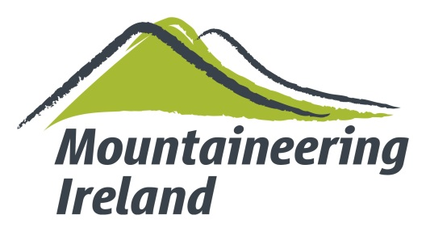 | Expedition Grant Application Form
While certain sections of this application form may not apply to you and your plans, please complete it as fully as possible and append any other relevant information.

Contact Information
Name of expedition
Name, phone number and email of the person to whom correspondence should be addressed
Please provide the following for the expedition leader:
Name
Address
Mountaineering Ireland Membership Number
Name of club or Individual Number
Mobile Number
E-Mail Address

Expeditions Details
Region to be visited
Objectives
Has this mountain/route been climbed previously? Yes or No
If yes, when
Has the mountain/route had an Irish Ascent? Yes or No
If yes, by whom and when
Who have you consulted about the expedition?
Identify your chief source(s) of information in relation to the proposed objectives.
Specify the proposed style of climb
Is any assistance being sought from an agent or guide? Yes or No
If yes, please specify the level of assistance being sought (including name of company/guide involved).

Permits
Whom have you applied for permission to climb in the area?
When do you expect a decision?

Duration
Duration – From:
To:
Schedule: Approach
Acclimatisation
Climb
Departure

Expedition Members
Give name, age, membership of Mountaineering Ireland/club, and relevant experience of all expedition members, including those other than from Ireland. Care should be given to detailing in depth expeditionary experience, including climbing in the Greater Ranges, Alpine and Scottish routes, stating leaders, partners etc.

Budget
Expenses | € or £stg | Income | € or £stg
Travel |  | Personal contributions
Food and other stores |  | Grants received
Equipment |  | Grants expected
Insurance |  | Media Support
Peak fees |  | Donations
Hire of labour |  | Lectures
Agents fees |  | Miscellaneous
Miscellaneous
Contingency
TOTAL |  | TOTAL

Which other organisations have you applied to for grants?
Name | Amount applied for

Are there any major commercial sponsors?

What insurance arrangements have you made? (Including policy names and numbers)

Equipment: Is any special equipment required for the expedition? Yes or No
If Yes, please specify

Porters:
What arrangements have been made for local porters or other employees?
What provision is being made for their compensation/evacuation in case of mishap?

Cultural/Geographic Scientific/aspects
What steps have been taken to study the area to be visited, in particular its geography, its political situation and its language?

Specify any scientific objectives of the expedition:

Give previous scientific or exploratory work:

Have your plans been discussed with any official scientific bodies concerned? What arrangements will be made for working out the results of your observations and for publishing them?

Do you agree to comply with the requirements of paragraphs 9 and 10 of the Expedition Grant -Guidelines

Give any additional information which you think may help the Mountaineering Ireland in arriving at a decision.

Will the expedition seek grant aid from others?

In the event of financial assistance being granted to your expedition, please specify the following:
Name of Bank Account
Account Number
Sort Code
IBAN
BIC

Give the names, addresses, phone number and e-mail address of two referees whom Mountaineering Ireland may contact concerning the general standing and bonafides of the expedition and its members
Referee 1
Name
Address
Phone number
E-mail address
Referee 2
Name
Address
Phone number
E-mail address

Declaration:
I confirm that all the details entered in this form are accurate as far as I am aware.

The members of the Expedition have assured me that they have read and understood this application form and all other documents pertaining to it.

I guarantee that the technical skills and mountaineering capacities of the climbing members of the expedition are appropriate to our target.

I understand that it is a requirement of grant aid that Mountaineering Ireland must be acknowledged as a grant aider in all publications/news Releases/DVD’s and other items produced by the expedition. The Mountaineering Ireland logo must feature in any reports / DVD’s or T-Shirts etc. are produced and they must be used in consultation with the Mountaineering Ireland Office Staff.

I confirm that the expedition will abide by the UIAA Code of Ethics (The Kathmandu Declaration) and will comply in particular with the regulations in force in (insert name of country to be visited).

Signature of Leader
Print Name
On Behalf of
Date
(Leaders are reminded that in the case of Nepal, the authorities at present require a letter of recognition from the National Body or Ambassador of the State of which an expedition member holds a passport, even if they are resident elsewhere. This is particularly important for UK passport holders in Northern Ireland who will have to get a letter from the BMC)

Applications will be considered by a panel of experts, which are in turn ratified by the Mountaineering Ireland Board of Directors. You will be informed of the MCI's decision as soon as possible.

Please return your completed application form to info@mountaineering.ie or post to:
Mountaineering Ireland
Irish Sport HQ
National Sports Campus
Blanchardstown
Dublin 15
D15 DY62

