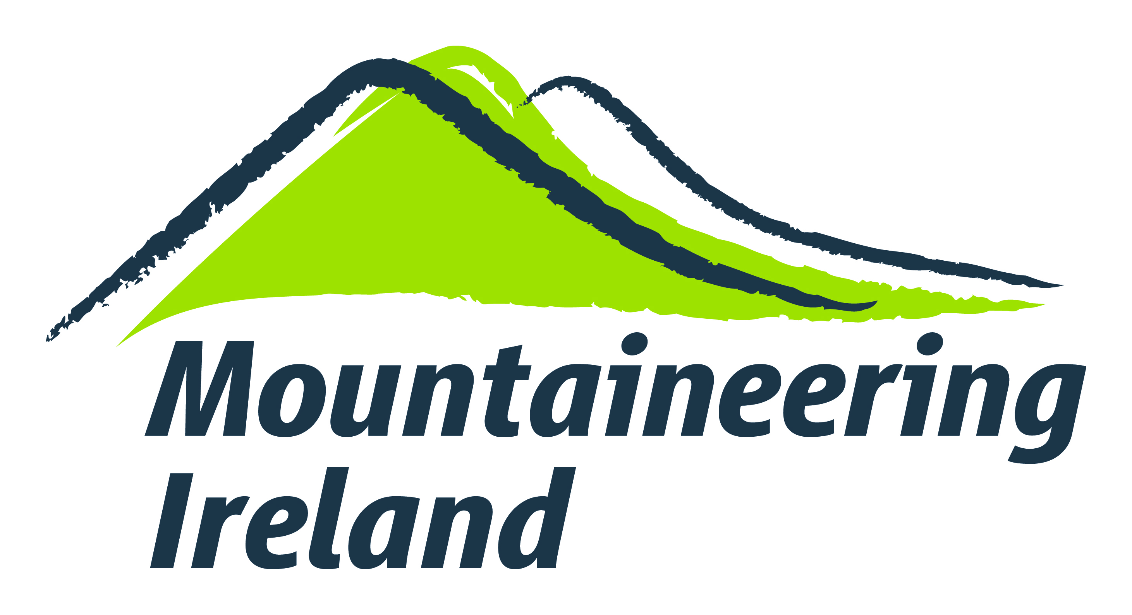

**Access Report Form**

Please use this form to report any difficulty you or your club have experienced in gaining access to the Irish hills and mountains, crags or coastal areas. You can include one-off incidents or ongoing situations that you are aware of. This information contributes to Mountaineering Ireland’s work at national level to secure improved access, it enables Mountaineering Ireland to provide better advice to members and it allows Mountaineering Ireland to identify trends or changes in the availability of access.

1. **Date and approximate time of incident:**
2. **Describe the location:**

OS 1:50k Map Number:    Grid reference:

1. **Describe the incident / situation:**

Please describe the type of situation or incident you have encountered as clearly as possible. State if you were alone or with a group. If you spoke with somebody, please give the person’s name or describe them. Try and recount as accurately as possible what was said, particularly any concerns that were expressed. Tell us anything else that you found out about the person, such as who they represented. Photographs of signs, obstructions etc. would also be helpful.

1. **Have you contacted anybody else as a result of this incident / situation?**
2. **Finally, please add your contact details:**

This is so that we can contact you to clarify any details or provide feedback. The identity of the individual or club making access reports will be kept confidential.

Name:

Address:

Phone number:

e-mail address:

Club (if relevant):

Please return this form by e-mail to [helen@mountaineering.ie](mailto:helen@mountaineering.ie) or post to Helen Lawless, Mountaineering Ireland, Irish Sport HQ, National Sports Campus, Blanchardstown, Dublin 15.

***Thank you for taking the time to provide this report!***